**Abstract**

Domestic gas is one of the essential supplies for our daily life, and most of the places we are in daily are not without gas cylinders. The severe neglect of the Yemeni Gas Company, organizing the distribution of the allocated quantities of domestic gas to the governorate of Aden, has become another concern that worries all citizens in Aden and the various governorates, Therefore, the idea of ​​the graduation project came to GASCO, which is a website that works on arranging and organizing the distribution of domestic gas in all the directorates of Aden Governorate.

**List of Table**

Contents

Tables of Data dictionray: Error! Bookmark not defined.

Table 2.3 Error! Bookmark not defined.

Table 2.3 citizens Error! Bookmark not defined.

Table 2.3 family_members Error! Bookmark not defined.

Table 2.3 observers Error! Bookmark not defined.

Table 2.3 employees Error! Bookmark not defined.

Table 2.3 gazlogs Error! Bookmark not defined.

Table 2.3 logbookings Error! Bookmark not defined.

Table 2.3 directorates Error! Bookmark not defined.

Table 2.3 rigons Error! Bookmark not defined.

Table 2.3 stations Error! Bookmark not defined.

Table 2.3 general_settings Error! Bookmark not defined.

**List of Figures**

Contents

Figures 1.1 Iterative Model Error! Bookmark not defined.

Figures 1.2 Gantt char Error! Bookmark not defined.

Figures 3.1 ERD Error! Bookmark not defined.

Figures 3.2 UML Error! Bookmark not defined.

Figures 4.1 admin algorithm Error! Bookmark not defined.

Figures 4.2 user algorithm Error! Bookmark not defined.

Figures 4.3 observer algorithm Error! Bookmark not defined.

Figures 4.4 citizen algorithm Error! Bookmark not defined.

Figures 1.4 Error! Bookmark not defined.

Figures 1.4 Error! Bookmark not defined.

Figures 1.4 Error! Bookmark not defined.

Figures 1.4 Error! Bookmark not defined.

**Table of contents**

Abstract 1

List of Table1

List of Figure1

Chapter One : 1

1.1 Introduction2

1.2 Problem Definition2

1.3 Goals Determine 2

1.4 information collection stage2

1.5 feasibility study 2

1.6 tools used in project2

1.7 methodology used in project2

1.8 project scope2

1.9 gant char2

Chapter Two :4

2.1 Background on the booking system5

2.2 Background on the existing system5

2.3 The mechanism of the existing system5

2.4 Description of the proposed system5

2.5 tools used in project5

Chapter three :4

3.1 system data analysis5

3.2 ERD (Entity Relation Diagram)5

3.3 DD (Data Dictionary)5

3.4 UML (use case diagram)5

Chapter Four :4

4.1 system algorithm5

4.1.1 algorithm6

4.1.2 advantages of algorithms6

4.1.3 the benefit of algorithms 6

Chapter five4

5.1 system interface5

**1.1 Introduction**

It is really unfortunate that the most that the citizen desires or that the dream of the citizen in Aden is to obtain a gas cylinder, and we do not know whether what Aden suffers from is a fabricated crisis or something else, but the reality now is that Aden suffers from a situation of wide and daily bottlenecks and a major crisis in the provision of gas cylinders It is a fact that cannot be denied or transcended as you watch large crowds of citizens in front of the distribution and sales points, long queues, a state of clamor and screaming, and a state of grumbling about the reality of the situation that the citizen has reached in Aden, which is the difficulty of obtaining a gas cylinder, which has become a difficult and difficult task and great suffering. It is very unimaginable for anyone to stand in long queues for hours to get a gas cylinder, Therefore, our project, GASCO is a website that works on arranging and organizing the distribution of domestic gas throughout the districts of Aden Governorate, and here we intend to transfer the work from working in the traditional way to a more accurate calculated work, which makes the process of booking and inquiring about payments and knowing the dates of reservations and making the delivery process practical Easy by sending text messages.

**1.2 Problem Definition**

**The existing system suffers from several problems, the main cause of which is the use of the traditional reservation system the biggest problems of the current system are summarized as follows:**

* Difficulty knowing the dates of reservations.
* Difficulty in completing the booking process.
* Difficulty knowing the delivery dates.
* Wasting a lot of time and effort and waiting in line under the sun for hours.
* Manipulation of the allocated amount and exploitation.
* Using the manual system in the reservations process
* Difficulty storing large amounts of data for a long time
* Difficulty generating reports
* Loss of credibility and confidence.

**1.3 Goals of project**

* Monitoring the disbursement of quantities allocated to the governorate of Aden.
* Solve the problem of waiting in the almost daily queues that all citizens suffer from.
* Not to tamper with the disbursement of the quantities allocated by the distributors.
* Solving the problem of the domestic gas crisis, which is the main goal.
* Facilitate the booking process by opening direct booking according to a specific mechanism.
* Facilitate the process of receiving by sending text messages.

**1.4 Information collection stage**

Systems analyst collects information from individuals or groups by interviewing. The analyst can be formal, legalistic, play politics, or be informal; as the

Success of an interview depends on the skill of analyst as interviewer.

Advantages of Interviewing

This method is frequently the best source of gathering qualitative information.

• Information can easily be validated and cross checked immediately.

• It can handle the complex subjects.

• It is easy to discover key problem by seeking opinions.

The interview was used

It is a direct conversation or dialogue between the system analyst and the user/users, during which questions are asked and their answers to those questions are recorded for the purpose of collecting the necessary information to determine the requirements and needs of the system.

Target group in the interview:

1. Citizens
2. Agents
3. Observer
4. Employees

Type of interview questions Open-ended questions were used by analyzing the personal interviews carried out by the project team members, which were conducted with the people related to the system, the following points were concluded:

1. The existing system is a manual system for booking
2. Determine user requirements of the new system
3. Understand the existing system and give an initial perception of the new system
4. The user needs an electronic system that facilitates work

**1.5 Feasibility Study**

Feasibility Study can be considered as preliminary investigation that helps the management to take decision about whether study of system should be feasible for development or not.

• It identifies the possibility of improving an existing system, developing a new system, and produce refined Estimates for further development of system.

• It is used to obtain the outline of the problem and decide whether feasible or appropriate solution exists or not.

• The main objective of a feasibility study is to acquire problem scope instead of solving the problem.

• The output of a feasibility study is a formal system proposal act as decision document which includes the complete nature and scope of the proposed system

* **1.5.1 Technical Feasibility Study**

It means identifying the technologies required for the proposed solutions with determining the cost and advantages that will result from their use.

**First**: the physical techniques of the proposed system:

They are all the equipment and devices that the system will work on, and they are as follows:

1. Non-recurring costs
2. Annual recurring costs
3. Optional costs

* Non-recurring costs

|  |  |
| --- | --- |
| Material | Cost |
| PC (i3, CPU 2 G.H ,RAM 1 G.B) | 400$ |
| Electrical storage | 100$ |
| internet line | 80$ |
| modem | 50$ |

* Annual recurring costs

|  |  |
| --- | --- |
| Material | Cost |
| internet subscription | 300$ |
| Website hosting subscription | 200$ |

* Optional costs

|  |  |
| --- | --- |
| Material | Cost |
| Printer | 300$ |
| Papers 4A | 200$ |

**Second**: the software techniques of the proposed system

These are the programs that must be downloaded to the device in order for the system to work, as follows:

1. Web browsers (Chrome, Firefox, etc…)
2. Operating system (Windows 7, 10 , 11 )

We conclude from the following technical feasibility study:

Due to the availability of physical and software techniques in the market and the possibility of obtaining them easily, we find that the system is technically feasible.

* **1.5.2 Time Feasibility Study**

It means the time difference between the existing system and the new system in executing the task. We conclude from the following time feasibility study:

And we looked at the implementation of the system for the required tasks in a faster time than the existing system, so we can say that the system is feasible in time.

* **1.5.3 Social Feasibility Study**

The site serves the community by providing information easily, facilitating the reservation process, knowing delivery dates, and providing services with ease, through study, and reviewing the opinions of citizens Through the field visit, we found that they have the desire and acceptance of the idea of ​​creating a website to arrange the distribution of domestic gas, so we can say that the system is considered socially feasible because it provides facilities for the community.

**1.6 Live cycle Used in Project**

**1.6.1 What is an iterative model?**

According to an iterative model, you can start with some of the software requirement specifications (SRS) and develop the first version of the software. After the first version if there is a need to change the software then a new version of the software is created with a new iteration.

**1.6.2 When to use the Iterative model?**

When the project is large.

When requirements are clear.

When there is a need for more quality in software.

New technology is being used

**1.6.3 Advantages of iterative model:**

* Supporting frequently Changed Requirements
* Supporting high risk projects.
* Guarantee of Success.
* Long term project.
* Complex Project.
* Easy to Implement.
* Flexible.
* Maintainable.

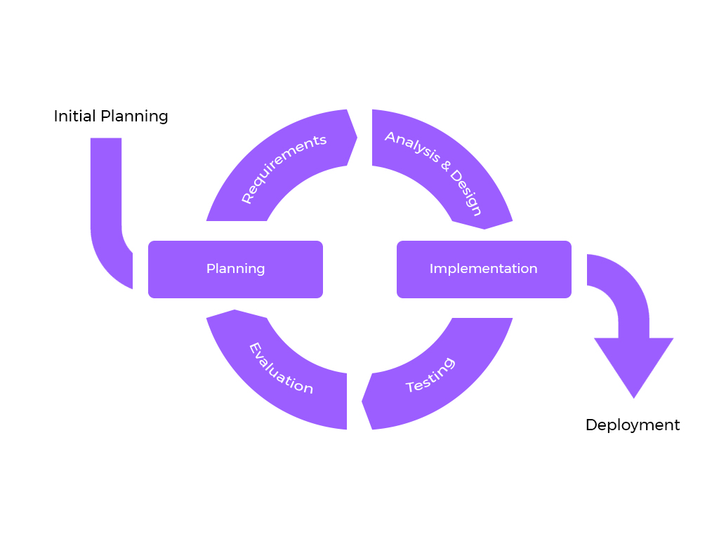

Figure 1.1 Iterative Model

**1.7 Project Scope**

The place where the project begins and the place where it ends what is included and excluded from the project

* **Functional Scope** :

The system provides functional services for:

1. Staff (system administrator or user)
2. Agents
3. Observer
4. Citizens

* **Spatial scope** :

All people who deal with the system, search or query from anywhere in Aden Governorate.

* **Temporal scope** :

The system is used at any time, provided that the Internet and a device to view the site, whether a computer or tablet, are available

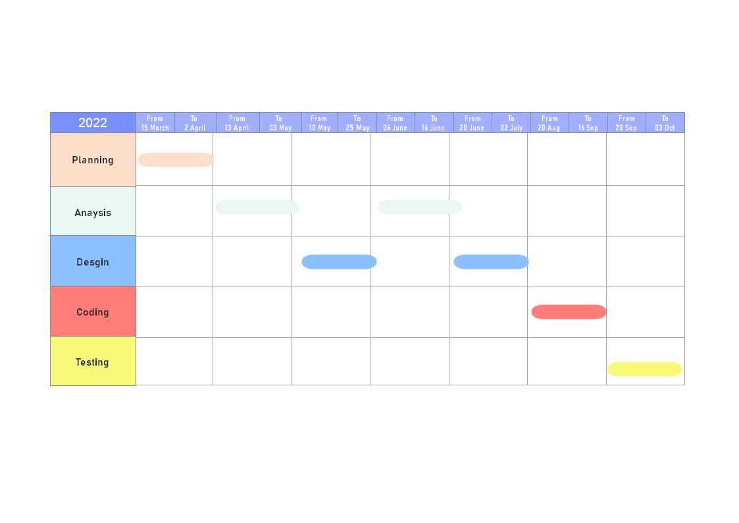

**1.8 Time Line (Gantt chart)**

Figure 1.2 Gantt Char

Theoretical

Background

**2.1 Background on the booking system:**

* **2.1.1 Definition of booking:**

It is a prior request for a service, whether this service is provided by Gasco, a hotel or other service providers, and the reservation is stored either manually (manual system) or by computer (electronic system).

* **2.1.2 Evolution of the booking process:**

The booking process has developed at the present time after it was done by traditional methods such as forcing the presence of the customer in order for the booking process to take place. It is now available with the push of a button, thanks to the spread of the Internet and smart phones. There are many electronic booking platforms spread on the Internet, most of which are available as applications for smart phones.

* **2.1.3 The traditional booking system:**

It is a pre-order for the service in the usual traditional ways in which the customer, agent or observer must attend and request the service for reservation. After the reservation process is completed, the observer customer or agent must follow up to find out the delivery date. After confirming the delivery date, the customer will cancel the reservation in case the customer is late for the delivery date.

* **2.1.4 Electronic booking system:**

It is a computerized system used to store the query and make reservations for agencies, restaurants, hotels, airlines and other service projects, which allows customers to service the query and the reservation process via the Internet.

* **2.1.5 Advantages of electronic booking systems:**
* Keeping pace with the era of modern technology.
* Facilitate the booking process and know the delivery dates.
* The ability to provide an integrated service with the least time and effort.
* Facilitate administrative processes**.**

**2.2 Background on the existing system:**

There are many service projects that serve the citizen, and among these service projects are domestic gas distribution services, where the system based on serving citizens works in arranging gas distribution and limiting manipulation in the disbursement of allocated quantities.

**2.3 The mechanism of the existing system:**

The existing system is a traditional manual reservation system.

* **2.3.1 The mechanism used by the citizen for booking:**

The citizen inquires about the dates of the reservation. In the event that the reservation is possible, the reservation process is carried out after the reservation process is confirmed, in which the citizen, the observer or the agent must follow up to find out the date of delivery.

* **2.3.2 The mechanism used by the observer for booking:**

In the event that the date of issuance of the quantity is known, the observer will open the reservation process, and after completing the reservation process, the observer will confirm the date of disbursing the quantity through the booking logs.

**2.4 Description of the proposed system:**

A website that arranges the distribution of domestic gas for the governorate of Aden. The system consists of the system administrator, system users, observer, agents and citizens.

* **2.4.1 Operations performed by the proposed system:**
* Custom Quantity Disbursement Management
* Issuing monthly and annual reports
* Verify citizens' data
* Complaint reception
* Manage booking
* Open booking
* Inquiries about booking dates
* The process of receiving an electronic booking
* Send receipt date
* Confirm receipt
* Inquiries about booking
* Payment Inquiry

**2.5 Tools Used In Project Building**

* **Hardware**

1. **PC**

* **Software**

**2.5.1 PHP – Programming Language:**

The abbreviation PHP initially stood for Personal Homepage. But now it is a recursive acronym for Hypertext Preprocessor. (It's recursive in the sense that the first word itself is an abbreviation, so the full meaning doesn't follow the abbreviation.)

The first version of PHP was launched 26 years ago. Now it's on version 8, released in November 2020, but version 7 remains the most widely used.

PHP runs on the Zend engine, which is the most popular implementation. There are some other implementations as well, like parrot, HPVM (Hip Hop Virtual Machine), and Hip Hop, created by Facebook.

PHP is mostly used for making web servers. It runs on the browser and is also capable of running in the command line. So, if you don't feel like showing your code output in the browser, you can show it in the terminal.

## **2.5.1.1 Advantages of PHP:**

* PHP has some advantages that have made it so popular, and it's been the go-to language for web servers for more than 15 years now. Here are some of PHP's benefits:
* Cross-Platform: PHP is platform-independent. You don't have to have a particular OS to use it because it runs on every platform, whether it's Mac, Windows, or Linux.
* Open Source: PHP is open source. The original code is made available to everyone who wants to build upon it. This is one of the reasons why one of its frameworks, Laravel, is so popular.
* Easy to learn: PHP is not hard to learn for absolute beginners. You can pick it up pretty if you already have programming knowledge.
* PHP syncs with all Databases: You can easily connect PHP to all Databases, relational and non-relational. So it can connect in no time to MySQL, Postgress, MongoDB, or any other database.
* Supportive Community: PHP has a very supportive online community. The official documentation provides guides on how to use the features and you can easily get your problem fixed while stuck.

**2.5.2 Laravel – Backend Framework:**

Laravel is an open-source PHP framework, which is robust and easy to understand. It follows a model-view-controller design pattern. Laravel reuses the existing components of different frameworks which helps in creating a web application. The web application thus designed is more structured and pragmatic.

Laravel offers a rich set of functionalities which incorporates the basic features of PHP frameworks like CodeIgniter, Yii and other programming languages like Ruby on Rails. Laravel has a very rich set of features which will boost the speed of web development.

If you are familiar with Core PHP and Advanced PHP, Laravel will make your task easier. It saves a lot time if you are planning to develop a website from scratch. Moreover, a website built in Laravel is secure and prevents several web attacks.

**2.5.2.1 Advantages of Laravel**

* The web application becomes more scalable, owing to the Laravel framework.
* Considerable time is saved in designing the web application, since Laravel reuses the components from other framework in developing web application.
* It includes namespaces and interfaces, thus helps to organize and manage resources.
  + 1. **Ajax technique:**

AJAX stands for Asynchronous JavaScript and XML. AJAX is a new technique for creating better, faster, and more interactive web applications with the help of XML, HTML, CSS, and Java Script.

* Ajax uses XHTML for content, CSS for presentation, along with Document Object Model and JavaScript for dynamic content display.
* Conventional web applications transmit information to and from the sever using synchronous requests. It means you fill out a form, hit submit, and get directed to a new page with new information from the server.
* With AJAX, when you hit submit, JavaScript will make a request to the server, interpret the results, and update the current screen. In the purest sense, the user would never know that anything was even transmitted to the server.
* XML is commonly used as the format for receiving server data, although any format, including plain text, can be used.
* AJAX is a web browser technology independent of web server software.
* A user can continue to use the application while the client program requests information from the server in the background.
* Intuitive and natural user interaction. Clicking is not required, mouse movement is a sufficient event trigger.
* Data-driven as opposed to page-driven.

**2.5.4 MySQL – Database**

MySQL is the most popular Open Source Relational SQL database management system. MySQL is one of the best RDBMS being used for developing web-based software applications.

MySQL is a fast, easy-to-use RDBMS being used for many small and big businesses. MySQL is developed, marketed and supported by MySQL AB, which is a Swedish company. MySQL is becoming so popular .

**2.5.4.1 advantages of MySQL:**

* MySQL is released under an open-source license. So you have nothing to pay to use it.
* MySQL is a very powerful program in its own right. It handles a large subset of the functionality of the most expensive and powerful database packages.
* MySQL uses a standard form of the well-known SQL data language.
* MySQL works on many operating systems and with many languages including PHP, PERL, C, C++, JAVA, etc.
* MySQL works very quickly and works well even with large data sets.
* MySQL is very friendly to PHP, the most appreciated language for web development.
* MySQL supports large databases, up to 50 million rows or more in a table. The default file size limit for a table is 4GB, but you can increase this (if your operating system can handle it) to a theoretical limit of 8 million terabytes (TB).
  + 1. **HTML – Frontend**

HTML stands for Hyper Text Markup Language, which is the most widely used language on Web to develop web pages. HTML was created by Berners-Lee in late 1991 but "HTML 2.0" was the first standard HTML specification which was published in 1995. HTML 4.01 was a major version of HTML and it was published in late 1999. Though HTML 4.01 version is widely used but currently we are having HTML-5 version which is an extension to HTML 4.01, and this version was published in 2012.

**2.5.5.1 advantages of HTML:**

* Create Web site - You can create a website or customize an existing web template if you know HTML well.
* Become a web designer - If you want to start a career as a professional web designer, HTML and CSS designing is a must skill.
* Understand web - If you want to optimize your website, to boost its speed and performance, it is good to know HTML to yield best results.
* Learn other languages - Once you understands the basic of HTML then other related technologies like JavaScript, php, or angular are become easier to understand.

**2.5.6 CSS – Frontend**

Cascading Style Sheets, fondly referred to as CSS, is a simple design language intended to simplify the process of making web pages presentable.

CSS handles the look and feel part of a web page. Using CSS, you can control the color of the text, the style of fonts, the spacing between paragraphs, how columns are sized and laid out, what background images or colors are used, layout designs, variations in display for different devices and screen sizes as well as a variety of other effects.

CSS is easy to learn and understand but it provides powerful control over the presentation of an HTML document. Most commonly, CSS is combined with the markup languages HTML or XHTML.

**2.5.6.1 Advantages of CSS:**

* CSS saves time − You can write CSS once and then reuse same sheet in multiple HTML pages. You can define a style for each HTML element and apply it to as many Web pages as you want.
* Pages load faster − If you are using CSS, you do not need to write HTML tag attributes every time. Just write one CSS rule of a tag and apply it to all the occurrences of that tag. So less code means faster download times.
* Easy maintenance − To make a global change, simply change the style, and all elements in all the web pages will be updated automatically.
* Superior styles to HTML − CSS has a much wider array of attributes than HTML, so you can give a far better look to your HTML page in comparison to HTML attributes.
* Multiple Device Compatibility − Style sheets allow content to be optimized for more than one type of device. By using the same HTML document, different versions of a website can be presented for handheld devices such as PDAs and cell phones or for printing.
* Global web standards − Now HTML attributes are being deprecated and it is being recommended to use CSS. So its a good idea to start using CSS in all the HTML pages to make them compatible to future browsers.

**2.5.7 JavaScript – Frontend:**

JavaScript is a dynamic computer programming language. It is lightweight and most commonly used as a part of web pages, whose implementations allow client-side script to interact with the user and make dynamic pages. It is an interpreted programming language with object-oriented capabilities.

JavaScript was first known as Live Script, but Netscape changed its name to JavaScript, possibly because of the excitement being generated by Java. JavaScript made its first appearance in Netscape 2.0 in 1995 with the name Live Script. The general-purpose core of the language has been embedded in Netscape, Internet Explorer, and other web browsers.

**2.5.7.1 Advantages of JavaScript:**

* Less server interaction − You can validate user input before sending the page off to the server. This saves server traffic, which means less load on your server.
* Immediate feedback to the visitors − They don't have to wait for a page reload to see if they have forgotten to enter something.
* Increased interactivity − You can create interfaces that react when the user hovers over them with a mouse or activates them via the keyboard.
* Richer interfaces − You can use JavaScript to include such items as drag-and-drop components and sliders to give a Rich Interface to your site visitors

Analysis

**3.1 System data analysis**

It is the process that has been and seen in the process of inspection and research in agricultural enterprises, to be more effective, accurate and then reconfigured and stored.

* **3.1.1 Data Modeling :**

In which the intrinsic properties of the system data are described by preparing the conceptual model of the data.

**3.2 ERD (Entity Relation Diagram)**

A template for describing databases

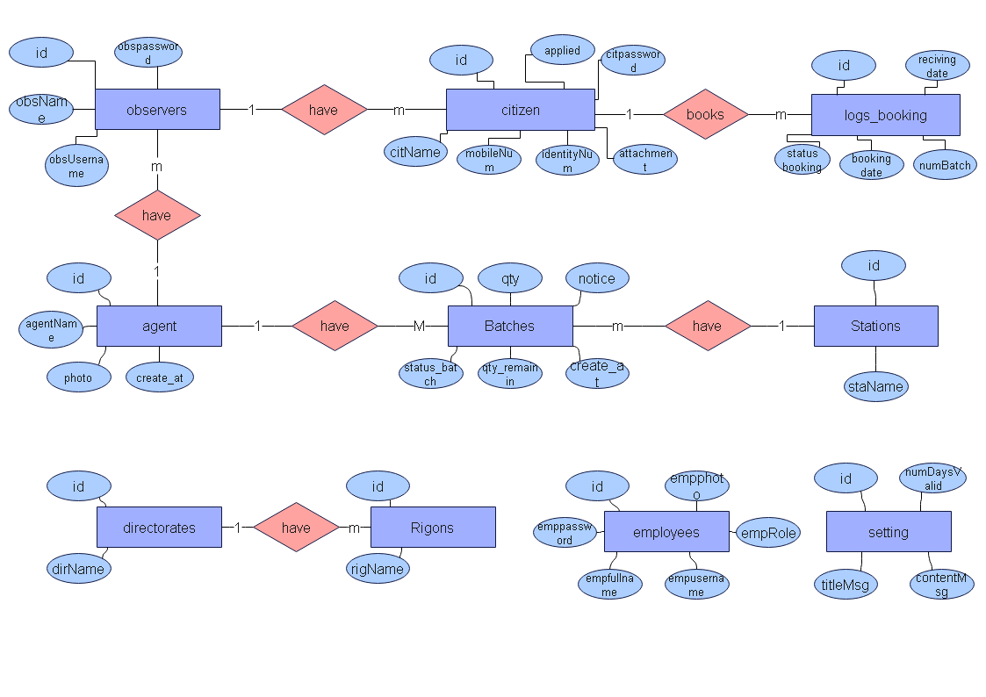

Figure 3.1 ERD

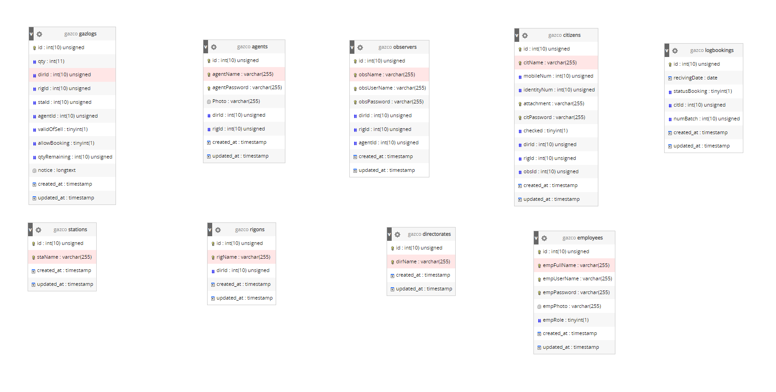

* **3.3 Data Dictionary**

**Data dictionary definition:**

It is a data dictionary that specifies the name and description of each of the elements that appear in the system, and is considered an essential reference in all stages of the system**.**

**Importance of a data dictionary:**

The importance of the data dictionary lies in the fact that it is a documentation of all elements of the system and is considered an important document of the system

**agents**

|  |  |  |  |
| --- | --- | --- | --- |
| Column | **Type** | **Links to** | **Description** |
| id *(Primary)* | int(10) |  |  |
| agentName | varchar(255) |  |  |
| agentPassword | varchar(255) |  |  |
| Photo | varchar(255) |  |  |
| dirId | int(10) | directorates -> id |  |
| rigId | int(10) | rigons -> id |  |
| created_at | timestamp |  |  |
| updated_at | timestamp |  |  |

**citizens**

|  |  |  |  |
| --- | --- | --- | --- |
| Column | **Type** | **Links to** | **Description** |
| id *(Primary)* | int(10) |  |  |
| citName | varchar(255) |  |  |
| mobileNum | varchar(255) |  |  |
| identityNum | int(10) |  |  |
| attachment | varchar(255) |  |  |
| citPassword | varchar(255) |  |  |
| checked | tinyint(1) |  |  |
| dirId | int(10) | directorates -> id |  |
| rigId | int(10) | rigons -> id |  |
| obsId | int(10) | observers -> id |  |
| created_at | timestamp |  |  |
| updated_at | timestamp |  |  |

**family_members**

|  |  |  |  |
| --- | --- | --- | --- |
| Column | **Type** | **Links to** | **Description** |
| id *(Primary)* | int(10) |  |  |
| fmName | varchar(255) |  |  |
| identityNum | int(10) |  |  |
| relationship | int(11) |  |  |
| sex | tinyint(1) |  |  |
| age | int(11) |  |  |
| citId | int(10) | citizens -> id |  |
| created_at | timestamp |  |  |
| updated_at | timestamp |  |  |

**observers**

|  |  |  |  |
| --- | --- | --- | --- |
| Column | Type | Links to | Description |
| id *(Primary)* | int(10) |  |  |
| obsName | varchar(255) |  |  |
| obsUserName | varchar(255) |  |  |
| obsPassword | varchar(255) |  |  |
| dirId | int(10) | directorates -> id |  |
| rigId | int(10) | rigons -> id |  |
| agentId | int(10) | agents -> id |  |
| created_at | timestamp |  |  |
| updated_at | timestamp |  |  |

**employees**

|  |  |  |
| --- | --- | --- |
| Column | **Type** | **Description** |
| id *(Primary)* | int(10) |  |
| empFullName | varchar(255) |  |
| empUserName | varchar(255) |  |
| empPassword | varchar(255) |  |
| empPhoto | varchar(255) |  |
| empRole | tinyint(1) |  |
| created_at | timestamp |  |
| updated_at | timestamp |  |

**gazlogs**

|  |  |  |  |
| --- | --- | --- | --- |
| Column | **Type** | **Links to** | **Description** |
| id *(Primary)* | int(10) |  |  |
| qty | int(11) |  |  |
| dirId | int(10) | directorates -> id |  |
| rigId | int(10) | rigons -> id |  |
| staId | int(10) | stations -> id |  |
| agentId | int(10) | agents -> id |  |
| statusBatch | varchar(255) |  |  |
| qtyRemaining | int(10) |  |  |
| notice | longtext |  |  |
| created_at | timestamp |  |  |
| updated_at | timestamp |  |  |

**logbookings**

|  |  |  |  |
| --- | --- | --- | --- |
| Column | Type | Links to | Description |
| id *(Primary)* | int(10) |  |  |
| recivingDate | date |  |  |
| statusBooking | tinyint(1) |  |  |
| citId | int(10) | citizens -> id |  |
| numBatch | int(10) |  |  |
| created_at | timestamp |  |  |
| updated_at | timestamp |  |  |

**directorates**

|  |  |  |
| --- | --- | --- |
| Column | Type | Description |
| id *(Primary)* | int(10) |  |
| dirName | varchar(255) |  |
| created_at | timestamp |  |
| updated_at | timestamp |  |

**rigons**

|  |  |  |  |
| --- | --- | --- | --- |
| Column | Type | Links to | Description |
| id *(Primary)* | int(10) |  |  |
| rigName | varchar(255) |  |  |
| dirId | int(10) | directorates -> id |  |
| created_at | timestamp |  |  |
| updated_at | timestamp |  |  |

**stations**

|  |  |  |
| --- | --- | --- |
| Column | Type | Comments |
| id *(Primary)* | int(10) |  |
| staName | varchar(255) |  |
| created_at | timestamp |  |
| updated_at | timestamp |  |

**general_settings**

|  |  |  |
| --- | --- | --- |
| Column | Type | Comments |
| id *(Primary)* | int(10) |  |
| numDaysBookingValid | int(11) |  |
| nameMessage | varchar(255) |  |
| contentMessage | varchar(255) |  |
| profilePhoto | varchar(255) |  |
| created_at | timestamp |  |
| updated_at | timestamp |  |

* **3.4 Use Case Diagram**

It is one of the Unified Modeling Language (UML) schemas, which is a model that represents the interaction of users with each other, the system’s interaction with itself, or the user’s interaction with the system.

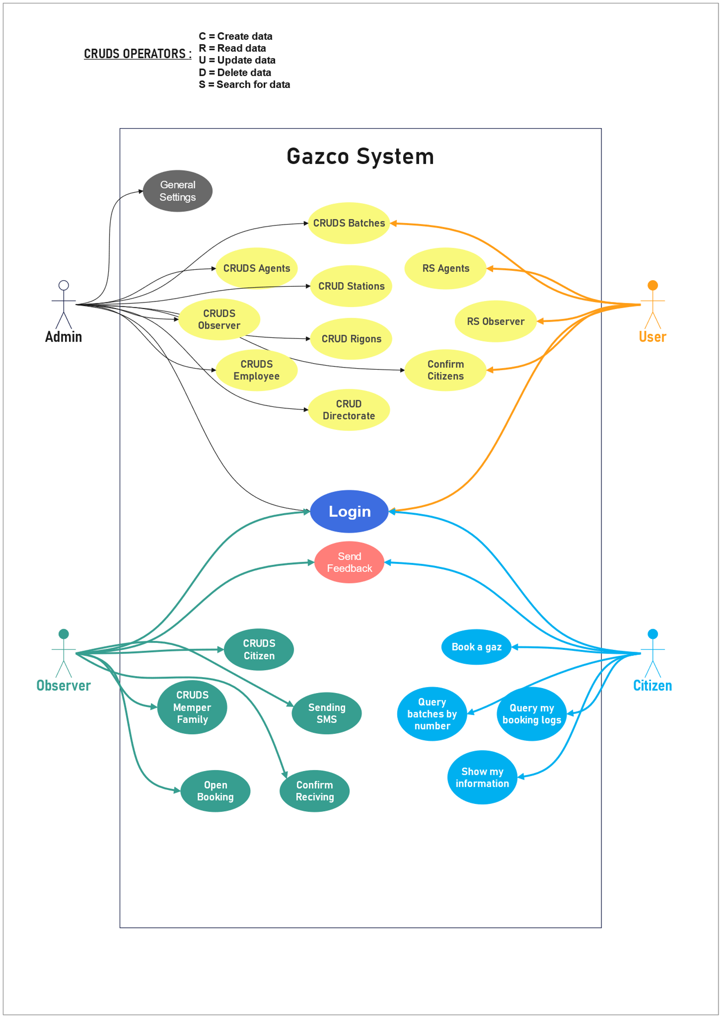

Design

**4.1 system algorithms**

* **4.1.1 Algorithm:**

It is a set of specific sequential steps that lead to solving a problem and reaching specific results

* **4.1.2 Advantages of Algorithms:**

1. Clearly describe the steps for the solution
2. The algorithm does not depend on a specific method of processing
3. The possibility of using the same algorithm to solve all similar problems.
4. Ease of understanding and understanding the steps of solving a problem.
5. The possibility of detecting errors easily.

* **4.1.3 The benefit of algorithms:**

1. Simplicity in solving complex problems.
2. Explain the program steps in a comprehensive and detailed manner.
3. Facilitate the process of tracking errors in the program.

data : username,password

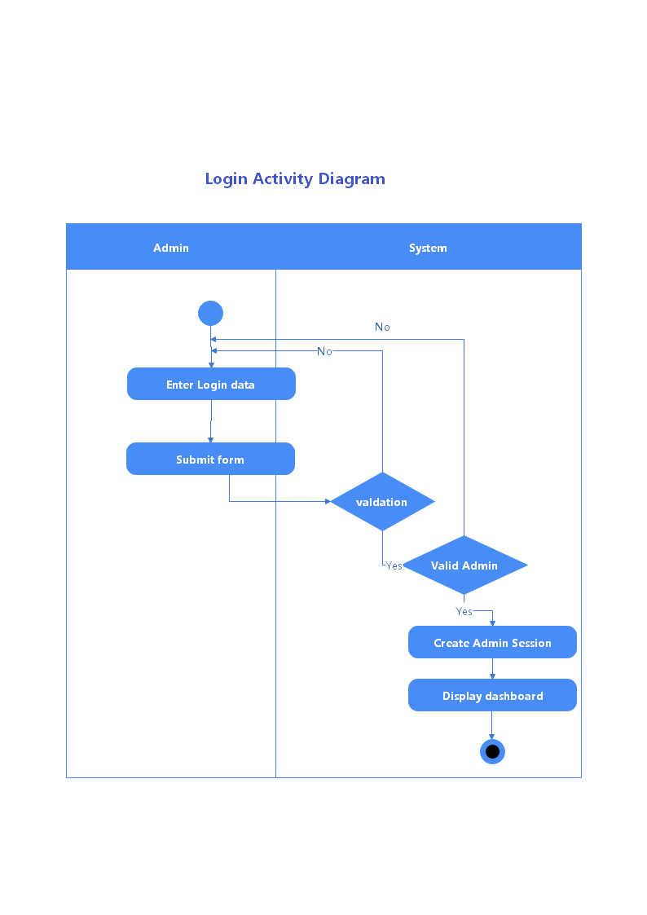

Figure 4.1 Login admin activity

data : username,password

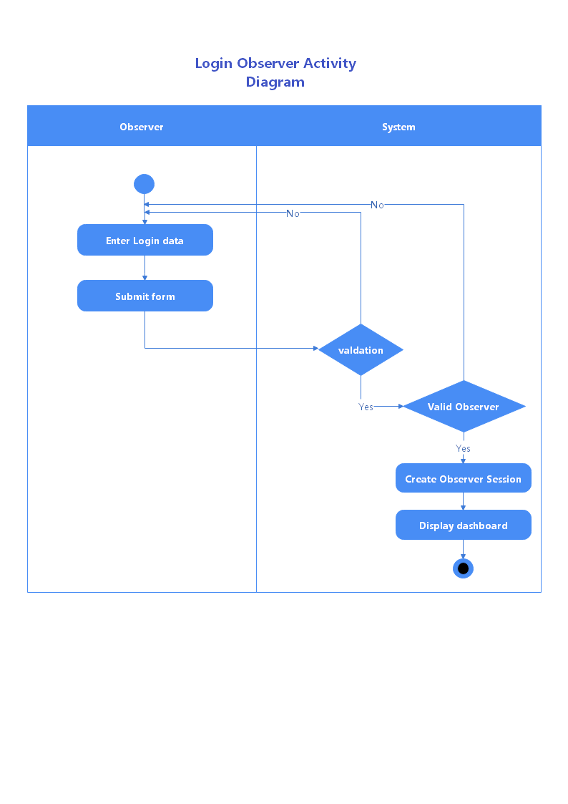

Figure 4.2 Login observer activity

data : identifyNumber,password



Figure 4.3 Login citizen activity

data : username,password

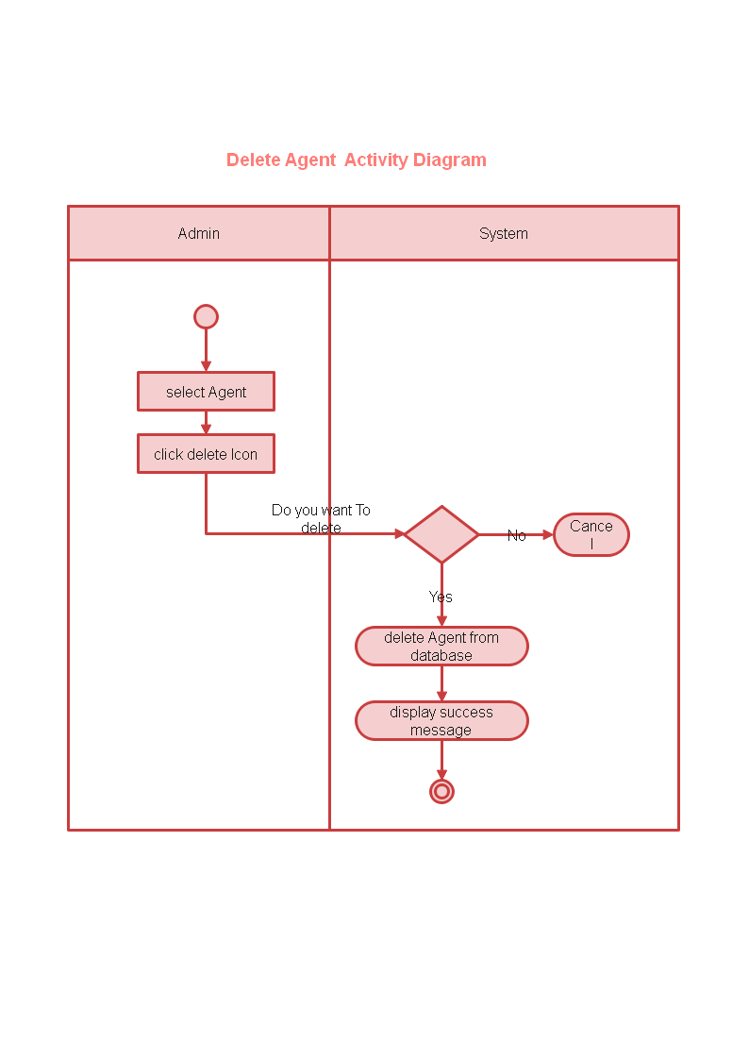

Figure 4.1 Login activity

data : username,password



Figure 4.1 Login activity

data : username,password



Figure 4.1 Login activity

data : username,password



Figure 4.1 Login activity

data : username,password



Figure 4.1 Login activity

data : username,password



Figure 4.1 Login activity

data : username,password



Figure 4.1 Login activity

data : username,password



Figure 4.1 Login activity

data : username,password



Figure 4.1 Login activity

data : username,password



Figure 4.1 Login activity

data : username,password



Figure 4.1 Login activity

data : username,password



Figure 4.1 Login activity

data : username,password



Figure 4.1 Login activity

data : username,password



Figure 4.1 Login activity

Implementation